2023 Call for Award Nominations

The Association of Midwest Museums (AMM) encourages members to submit nominations for the following categories of awards to recognize organizations and individuals throughout the Midwest region for their leadership, career achievements, creativity, and best practices.

- Distinguished Career Award: The Distinguished Career Award recognizes individuals (paid staff, board members, and volunteers) at mid- to late-museum career stages whose leadership, vision, mentorship, and creativity have—over the course of their careers—had a positive impact on staff and community members and/or resulted in lasting change for their institutions. Individuals | Mid-Career | Late Career.

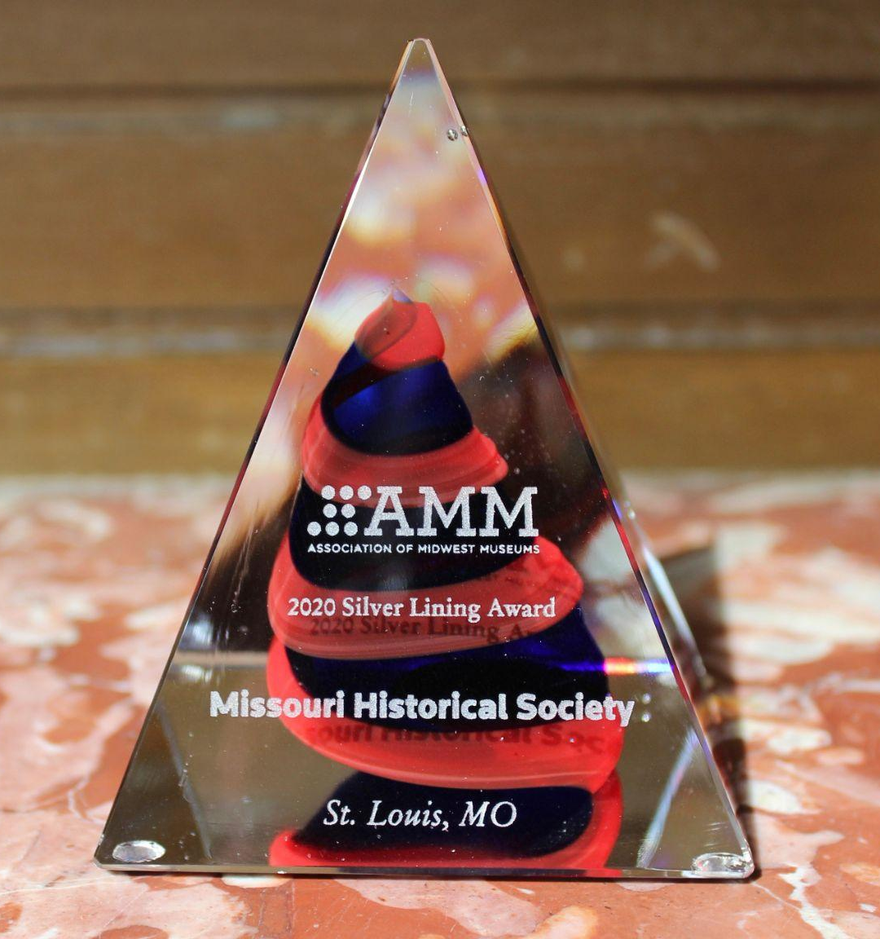
- Promising Leadership Award: The Promising Leadership Award recognizes the commitment and service of individuals (paid staff, interns, board members, and volunteers) in the early stages of their museum careers who have demonstrated leadership prowess through the implementation of projects or through service to teams/departments. Individuals | Early Career |

- Best Practices Award: The Best Practices Award recognizes museums and cultural organizations whose innovative projects (exhibitions, collections stewardship, programs, virtual or in-person) or community partnerships and collaborations have pushed beyond the status quo and led to the advancement of best museum practices or the establishment of new practices at their institutions in order to better fulfill their missions. Nominated projects or initiatives must have been implemented by the time of nomination to be considered and resulted in new practices, knowledge, ideas, and/or replicable models for the museum profession at large. Institutions | Projects|

- Groundbreakers Award: The Groundbreakers Award recognizes museums or cultural organizations who have pushed past boundaries, broken conventions, addressed uncomfortable truths about their institution’s histories and connection to oppressive systems and structures, and/or creatively engaged collaborative partners to affect change in the pursuit of a better, more equitable, inclusive, and sustainable future. Nominees’ external or internal projects or initiatives—big or small—have resulted in better support for their staff and volunteers, greater service to their diverse communities, new thinking about their collections, or advancement of social justice work in their communities. Museums of any size are qualified and encouraged to apply, and will be honored for their internal or external efforts to advance diversity and equity at their institutions. Institutions | Projects|
Award Nomination Guidelines
All nominators are asked to provide a well-organized submission with careful consideration to what is relevant and meaningful. Be clear about why you, your colleague or organization is deserving of the award and in what ways they have achieved excellence. In addition, please note the following requirements for submissions:

- Submit nominations using our online form linked here by 11:59pm ET on May 5, 2023.

- AMM Membership is Required. All nominees must be current individual, or institutional members of the Association of Midwest Museums or employees of a member museum.

- Please attend the AMM conference. Recipients will receive one complimentary registration for this year’s conference to be held July 26-29 in Indianapolis, IN, and will be recognized at the Midwest Museums Recognition Lunch on Friday, July 28th.

- The following materials are required for Distinguished Career or Promising Leadership Awards nominations. PDF format preferred.
  - Nomination letter detailing the nominee’s qualifications for the award, examples of their work, and any stories that demonstrate their impact
  - Nominee’s resume or CV (max. 3 pages)
  - Supplemental information such as relevant photos or images or supporting letter(s) from staff, peers, or community members (one document, max. 5 pages)

- The following materials are required for Best Practices or Groundbreakers Awards nominations. PDF format preferred.
  - Nomination letter with a detailed description of the nominated project, initiative, program, exhibition, or achievement (maximum 2 pages) and when it occurred. Clearly articulate the outcomes or impact of the nominated program/initiative.
  - Brief profile of the organization (maximum one page) and any relevant partners
  - Supplemental information such as relevant photos or images or supporting letter(s) from staff, peers, or community members (one document, max. 5 pages)

Awards Selection and Announcement Process
The AMM Awards Committee will review all nominations following the close of the Call for Nominations. Nominating parties will be notified of the committee’s decision by June 1, 2023. Recipients will be announced publicly in July and recognized during an in-person recognition event on July 28 at historic Union Station in downtown Indianapolis, during the 2023 Conference. In addition, AMM will host a series of virtual celebrations in honor of the recipients in October - November, each featuring a dynamic program. These events will bring together the honorees' communities to celebrate, including staff and leadership, members and partners, and Midwestern peers. Event planning will occur in August - September.

