2021 Call for Award Nominations

The Association of Midwest Museums (AMM) encourages members to submit nominations for the following categories of awards to recognize organizations and individuals throughout the Midwest region for their leadership, career achievements, creativity, and best practices.

- Distinguished Career Award: The Distinguished Career Award recognizes individuals (paid staff or volunteers) at mid- to late-museum career stages whose leadership, vision, mentorship, and creativity have—over the course of their careers—had a positive impact on staff and community members and/or resulted in lasting change for their institutions.
Individuals | Mid-Career | Late Career.

- Promising Leadership Award: The Promising Leadership Award recognizes the commitment and service of individuals (paid staff, interns, or volunteers) in the early stages of their museum careers who have demonstrated leadership prowess through the implementation of projects or through service to teams/departments.
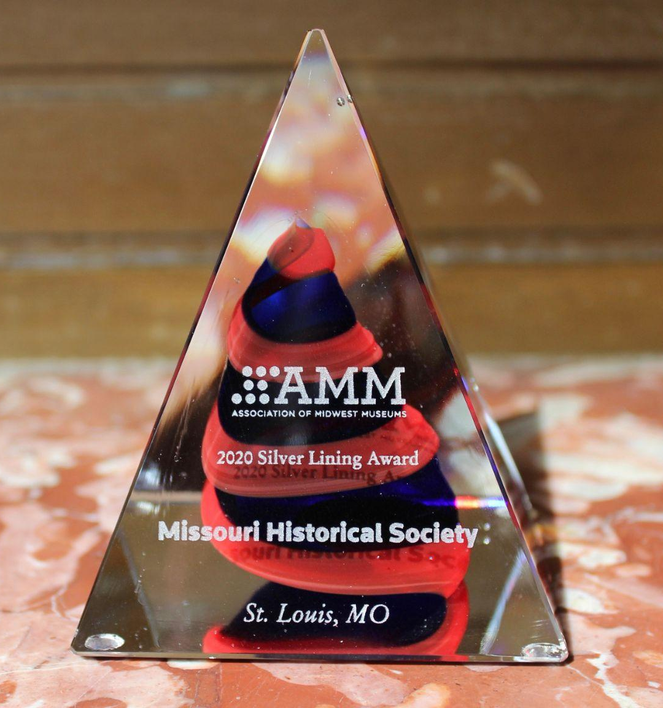
Individuals | Early Career |

- Best Practices Award: The Best Practices Award recognizes museums and cultural organizations whose innovative projects (exhibitions, programs, virtual or in-person) or community partnerships and collaborations have pushed beyond the status quo and led to the advancement of best museum practices or the establishment of new practices at their institutions in order to better fulfill their missions. Nominated projects or initiatives offer new ideas and/or replicable models for the museum profession at large.
Institutions |

- Groundbreakers Award: The Groundbreakers Award recognizes museums or cultural organizations who have pushed past boundaries, broken conventions, addressed uncomfortable truths about their institution’s histories and connection to oppressive systems and structures, and/or creatively engaged collaborative partners to affect change in the pursuit of a better, more equitable, inclusive, and sustainable future. Nominees’ external or internal projects or initiatives—big or small—have resulted in better support for their staff and volunteers, greater service to their diverse communities, or advancement of social justice work in their communities. Museums of any size are qualified and encouraged to apply. Up to two recipients, small and/or large institutions, will be honored for their internal or external efforts to advance diversity and equity at their institutions.
Institutions |
Award Nomination Guidelines
All nominators are asked to provide a well-organized submission with careful consideration to what is relevant and meaningful. Be clear about why you, your colleague or organization is deserving of the award and in what ways they have achieved excellence.

In addition, please note the following requirements for submissions:

- The deadline for submitting all nominations is 11:59pm ET on September 7, 2021.

- AMM Membership is Required. All nominees must be individual, institutional or corporate members of the AMM or employees of a member museum.

- Please attend the conference. AMM Awards recipients will receive one complimentary registration for the 2021 Virtual Conference to be held November 1-5, 2021 and are asked to participate. Recognition events will take place each day of the conference.

- Nominations for the Distinguished Career Award or the Promising Leadership Award must include at least one letter detailing the nominee’s qualifications for the award plus a resume or CV. Consider including letters from staff, peers, or community members whenever possible. Please combine all letters into a single document. You may also submit a PDF with relevant photos or images (maximum 5 pages). You may upload up to 3 total documents in the online form.

- Nominations for the Best Practices or Groundbreakers Awards must include a letter with a description of the nominated project, initiative, program, exhibition, or achievement (maximum 2 pages) plus a profile of the organization (maximum one page). You may also submit a PDF with relevant photos or images (maximum 5 pages). You may upload up to 3 total documents in the online form.

Awards Selection and Announcement Process
The AMM Awards Committee will review all nominations following the close of the Call for Nominations. We anticipate that nominating parties will be notified of the committee’s decision by October 1, 2021. Recipients will be announced publicly approximately 2-3 weeks prior to the awards recognition events and AMM-WFM 2021 Virtual Conference.

AMM will host a series of virtual community celebrations at approximately 4pm CT/ 5pm ET, Monday to Friday, November 1-5, featuring a dynamic program dedicated to the project or individual being recognized. These events will bring together the honorees' community to celebrate, including staff and leadership, members and partners, and Midwestern peers. Event planning will occur in the month of October.

